# CMSC 204 | Generics Lab

**Sousanna Chugunova**

Complete the following –

* Modify the DataSet class so that it becomes a **generic class**
  + Name the generic version as **DataSetGen.java**
    - public class DataSetGen<T extends Measurable> { …}
  + It should work only with classes that implements the **Measurable** interface
* Modify the main() method of DataSetTester so that you can run it
  + It utilizes **BankAccount** and **BaseballPlayer** (classes)
  + it uses the DataSetGen class
  + **DO not (no need to) make any changes** to the BankAccount nor BaseballPlayer classes
* In a small write-up
  + **Capture** one or more screen shots of your test runs
  + **Discuss** your learning experience in several paragraphs
* **Submit** a compressed file of your project folder (source code) and write-up

**Test Run:**

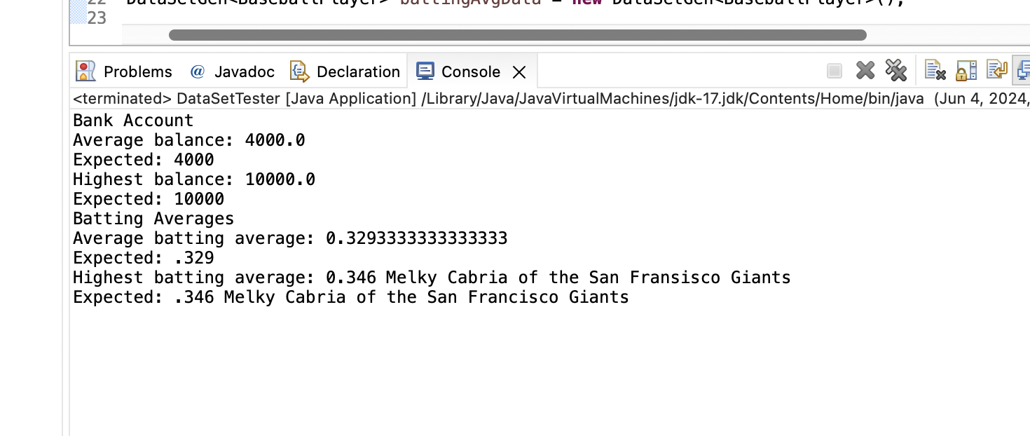

**Write Up:**

During this lab, I learned more about generic classes. Specifically, writing a class once and then being able to use it with different types of objects without having to rewrite the class for each type. This is done so that the code is “cleaner” and easier to read.

In my **DataSetGen** class, I added a private instance variable **maximum** of type **T**, which holds the maximum value found in the dataset. This variable allows the class to keep track of the maximum value efficiently.I also modified the add method signature to **public void add(T x)**, enabling the method to accept arguments of any type specified by the generic class. This method adds a data value **x** to the dataset and updates the maximum variable if necessary. Lastly, I adjusted the **public T getMaximum()**, method which returns the maximum value found in the dataset. This method uses the value stored in the maximum variable, ensuring that it can return values of the same type specified when creating an instance of the generic class. I also put all my files into one package named ‘Lab’.

The only part I found concerning. was that my ‘average batting average’ was a long decimal but in the expected output the decimal is only displayed to the thousandth. Other than that, I found the modifications to be straightforward and directions were easy to comprehend.